1. Find out how the code works to detect the browsers’ information. Run it on three different browsers: Firefox, Internet Explorer, and Google Chrome, and make sure to see the right information for each browser.
2. Google Chrome

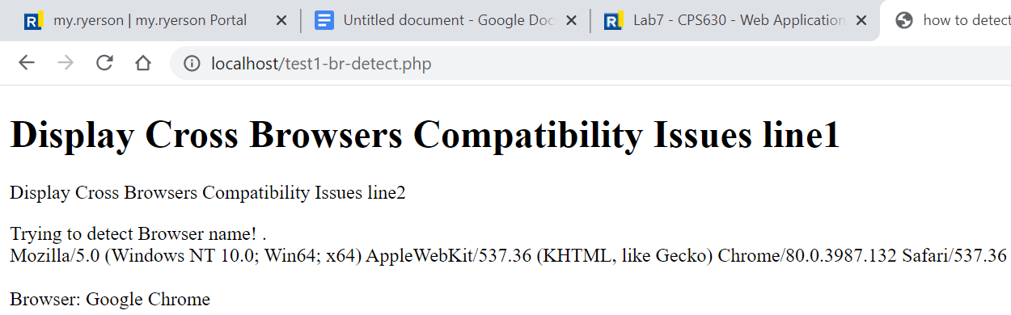

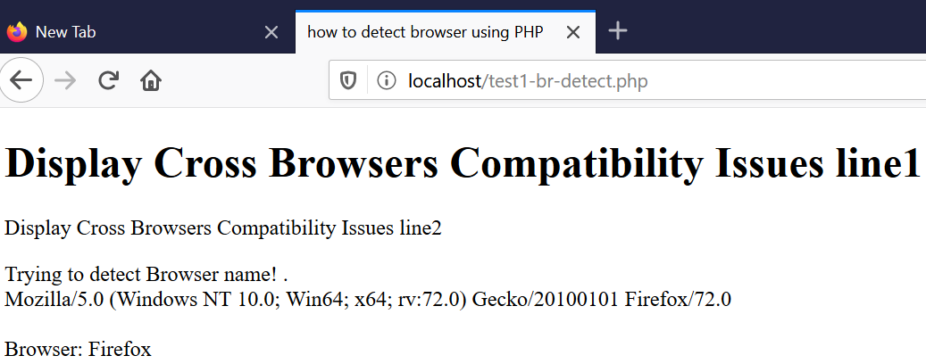

1. Firefox
2. Internet Explorer

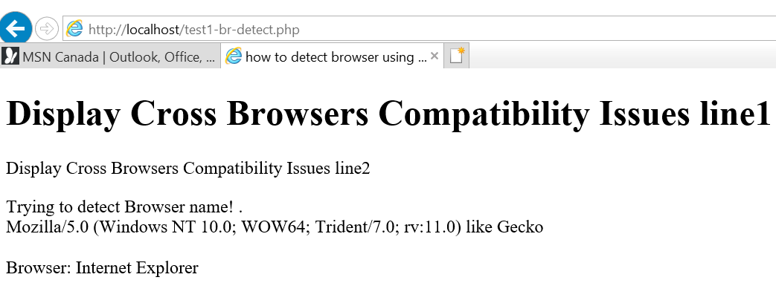

1. Write a code in JavaScript to do the same task (detecting the browser information) at the client-side. Your code should work on the same browsers as above. Note -Use “navigator.userAgent” to access the browser information. Also note that a browser name could be different on different platforms, for example “IE” might be known as “Trident” or “Internet Explorer” or other names.

JavaScript code (See test1-br-detect.js file):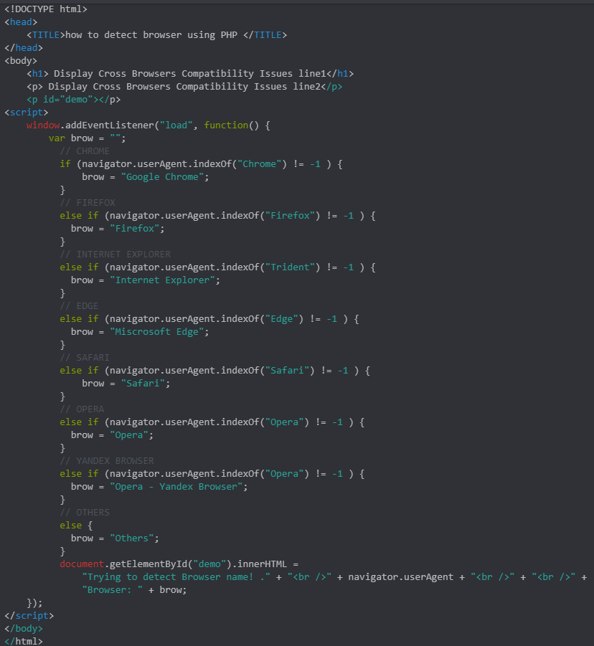

1. Google Chrome



1. Firefox



1. Internet Explorer

.